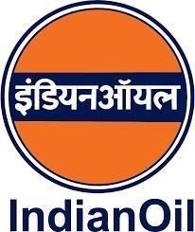

CHATBOT FOR IOCL SERVICES

Indian Oil Corporation Ltd., Panipat

Duration: 15/06/2024 – 13/07/2024

DAMINI
VT/2025-26/CS-069

BANASTHALI VIDYAPITH



Approved By: Mr. Shubham Modi (IS)
Date: 26/07/2025

ACKNOWLEDGEMENT

My indebtedness and gratitude to the many individuals who have helped to shape this report in its present form cannot be adequately conveyed in just a few sentences. Yet I must record my immense gratitude to those who helped me undergo this valuable learning experience at IOCL Panipat.
I am highly obliged to Mr. Pankaj Tripathi Sir, Training and Development Department for providing me this opportunity to learn at IOCL.
I would like to express my heartfelt gratitude to Mr. Shubham Modi Sir for his invaluable guidance and support throughout the duration of my internship period. His insights and expertise were instrumental in the successful development of the Human retina tacking model.
I am also deeply thankful to Hari Pal Singh Sir for his continuous encouragement and assistance, which greatly contributed to the project's progress. His practical advice and hands- on support were crucial in overcoming many challenges.
Furthermore, I would like to extend my sincere appreciation to Mr. Sushawant Meshram Sir (DGM) for his leadership and for providing the opportunity to work on this project. His direction and vision were vital in steering the project towards its successful completion.
Last but not the least I am thankful to my family and friends for their immense support and cooperation throughout the training period.

PREFACE
This report is submitted in partial fulfillment of the requirements for the successful completion of my internship at Indian Oil Corporation Limited (IOCL). The project titled “Chatbot System for IOCL Services Using Flask and MySQL” was undertaken with the aim of developing a user-centric and intelligent solution to enhance internal communication and selfservice capabilities within the organization.
In today’s fast-paced corporate environment, the timely dissemination of information is crucial. IOCL, being a leader in the energy sector, constantly strives to modernize its digital infrastructure. This project contributes to that initiative by implementing a web-based chatbot system that can efficiently respond to employee queries related to FAQs, holiday calendars, holiday home listings, and booking procedures. The system is built using Flask for the backend, MySQL for data handling, and HTML/CSS/JavaScript for the user interface.
The development of this chatbot not only helped automate repetitive HR interactions but also improved the speed and accessibility of essential employee services. The project emphasizes the integration of keyword mapping, fuzzy matching, and modular database-driven responses to make the chatbot more interactive and effective.
This report documents the entire development lifecycle, including requirement analysis, system design, database integration, frontend development, testing, and deployment. It also highlights the challenges encountered and the strategies adopted to overcome them.
This work has enhanced my technical proficiency and provided me with valuable insight into real-world software development, particularly within the domain of intelligent systems and enterprise automation.
I am confident that this project will serve as a foundation for future enhancements such as natural language processing (NLP), multilingual support, and voice integration to further enrich the user experience.

TABLE OF CONTENTS
Acknowledgements
Preface
Table of Contents
1. Introduction
- Overview of the Project
- Information Security Department Engagement
- Objectives
- Significance
2. System Design and Methodology
- Architectural Components
- Computer Vision
- Integration Details
3. Implementation
- System Setup
- Development Process
- Testing
- Maintenance and Iterative Improvement
- Results
- Challenges and Solutions
  - Challenges Faced During the Project
  - Solutions Implemented
- Conclusion
- References

INTRODUCTION
In the era of digital transformation, organizations across sectors are rapidly adopting technology-driven solutions to streamline operations, enhance efficiency, and improve employee engagement. One such initiative involves the implementation of intelligent chatbot systems capable of simulating human-like conversations to automate repetitive tasks and deliver instant responses. This project, titled “Chatbot System for IOCL Services Using Flask and MySQL,” is a step toward enhancing internal communication and self-service capabilities within Indian Oil Corporation Limited (IOCL)—India’s premier energy company.
IOCL, a Maharatna company, caters to millions of customers across India and abroad and employs thousands of individuals working in various departments. In large organizations like IOCL, employees often have queries related to HR policies, holiday schedules, guest house availability, and booking procedures. Traditionally, these queries are resolved through manual interaction with administrative staff, leading to increased workload, delayed responses, and inconsistencies. To address this challenge, the project aims to develop a web-based chat bot that provides real-time, accurate, and automated responses to internal employee queries.
The chat bot is built using Python (Flask framework) for backend logic, MySQL for database management, and HTML, CSS, and JavaScript for the user interface. It interacts with a structured database containing categorized information such as frequently asked questions (FAQs), holiday calendars, holiday home listings, and booking procedures. The integration of keyword mapping and fuzzy string matching ensures that the chat bot can understand and respond to a wide range of user inputs, even when phrased differently.
This report outlines the purpose, design, architecture, implementation, and testing phases of the chat bot system. It further explains how this project contributes to IOCL’s digital initiatives by promoting automation, improving access to information, and reducing administrative overhead.
In conclusion, the Chat bot System for IOCL is a meaningful innovation that not only aligns with the company’s vision of digital empowerment but also demonstrates the practical application of modern web technologies in enterprise environments.

Objectives
The primary objective of this project is to design and implement a web-based chatbot system to automate and enhance employee access to essential services and information within Indian Oil Corporation Limited (IOCL). The specific objectives of the project are as follows:
- To Develop an Intelligent Chatbot Interface
Build a user-friendly chatbot that can understand employee queries and provide accurate responses through a conversational interface.
- To Automate Frequently Asked Queries
Create a system that retrieves answers from a predefined set of FAQs, reducing the manual burden on administrative and HR personnel.
- To Provide Access to Holiday-Related Information
Enable users to retrieve details of upcoming holidays, festival dates, and official leave schedules from the holiday calendar database.
- To Display Holiday Home Listings
Allow employees to view the list of available IOCL holiday homes, including their locations and descriptions.
- To Inform Booking Procedures
Provide step-by-step guidance on how to book IOCL holiday homes, including login steps, availability check, and payment instructions.
- To Ensure Fast and Accurate Responses
Use keyword detection and fuzzy matching algorithms to understand user inputs even when phrased informally or partially.
- To Integrate a Scalable Backend Architecture
Utilize Flask and MySQL to build a scalable, maintainable, and modular backend capable of handling real-time queries.
- To Improve Internal Communication Efficiency
Minimize information delays and streamline access to frequently requested resources, thus promoting digital empowerment within the organization.

Significance

The Chatbot System for IOCL Services holds substantial significance in the context of digital transformation, employee self-service, and operational efficiency within Indian Oil Corporation Limited (IOCL). As one of India’s largest and most diversified energy companies, IOCL manages vast administrative processes and a large workforce spread across the nation. Timely access to internal services such as holiday information, booking procedures, and HR-related FAQs is crucial for maintaining organizational productivity.
This project introduces a chatbot-based interface that simplifies the process of information retrieval for employees, enabling them to obtain accurate answers instantly without human intervention. The chatbot reduces the workload on HR and administrative staff, thereby saving time, improving turnaround speed, and enhancing internal satisfaction.
By using modern web technologies such as Flask and MySQL, the chatbot system is designed to be scalable, efficient, and easy to deploy within IOCL's intranet. It also sets the groundwork for incorporating future advancements like natural language processing (NLP), multilingual support, and voice command recognition.
In essence, the project supports IOCL’s vision of automation and digital service delivery, contributing meaningfully to the company’s long-term goal of operational excellence and innovation in employee engagement.

SYSTEM DESIGN AND METHODOLOGY
The design and development of the Chatbot System for IOCL Services follow a modular and scalable approach to ensure reliability, responsiveness, and easy maintainability. The system is designed to simulate human-like interaction by responding to user queries about FAQs, holiday calendars, booking procedures, and holiday home details through a web interface.
- System Architecture
The chatbot architecture is divided into three primary components:
  - Frontend (Client Interface):
Developed using HTML, CSS, and JavaScript, the user interface allows employees to type queries and view chatbot responses in a conversational format. The UI is minimal, clean, and responsive to suit both desktop and mobile devices.
  - Backend (Application Logic):
Built using the Flask framework in Python, the backend handles routing, input processing, query classification, and response generation. It manages the logic for detecting intents (FAQs, holidays, homes, procedures) and querying the appropriate database table.
  - Database Layer:
MySQL is used to store structured information in four main tables:
o _{faqs} – Frequently asked questions and answers o holiday_calendar – List of holidays and dates o _{holiday_homes} – Holiday home names and locations o _{booking_procedure} – Step-by-step instructions for booking
- Methodology
The development methodology is iterative, following these key stages:
  - Requirement Gathering
Identified the most common internal queries and services accessed by IOCL employees.
  - Database Design
Structured and normalized MySQL tables to hold all necessary information.
  - Interface Design
Created a chatbot frontend with minimal input/output layout, styled using CSS, and supporting AJAX-based communication with the Flask backend.
  - Intent Detection
Implemented a keyword and fuzzy-matching system to classify queries into one of four intents: FAQ, holiday, holiday home, or procedure.
  - Data Retrieval
SQL queries are triggered based on detected intent, and formatted responses are returned to the frontend.
  - Testing and Validation
Tested various types of queries for robustness, flexibility, and accuracy in response.
  - Deployment (Localhost/Web) Deployed the application on Flask’s development server. The system is ready for integration into IOCL’s intranet environment.
- Tools and Technologies Used
  - Frontend: HTML, CSS, JavaScript
  - Backend: Python (Flask Framework)
  - Database: MySQL
  - Libraries: fuzzywuzzy, rapidfuzz, dotenv, mysql-connector-python

Integration Details

The integration of the IOCL Chatbot system ensures smooth communication between the frontend interface, Flask backend, and MySQL database.
- Frontend–Backend Integration
The HTML interface (_{frontjs.html}) captures user queries and sends them to the Flask backend (_{app.py}) using AJAX POST requests. JavaScript handles input and updates the chat window dynamically with chatbot responses.
- Backend–Database Integration
The backend uses Python’s mysql-connector-python to connect with the MySQL database (_{holiday_db}). Based on detected intent (FAQ, holidays, homes, or procedure), it executes corresponding SQL queries on tables like faqs, holiday_calendar, holiday_homes, and booking_procedure.
- Response Generation
The retrieved data is formatted as a chatbot reply and returned in JSON format to the frontend.
The response is then displayed to the user in real time.
This integration ensures a fully functional chatbot system capable of handling and responding to real-world queries efficiently.

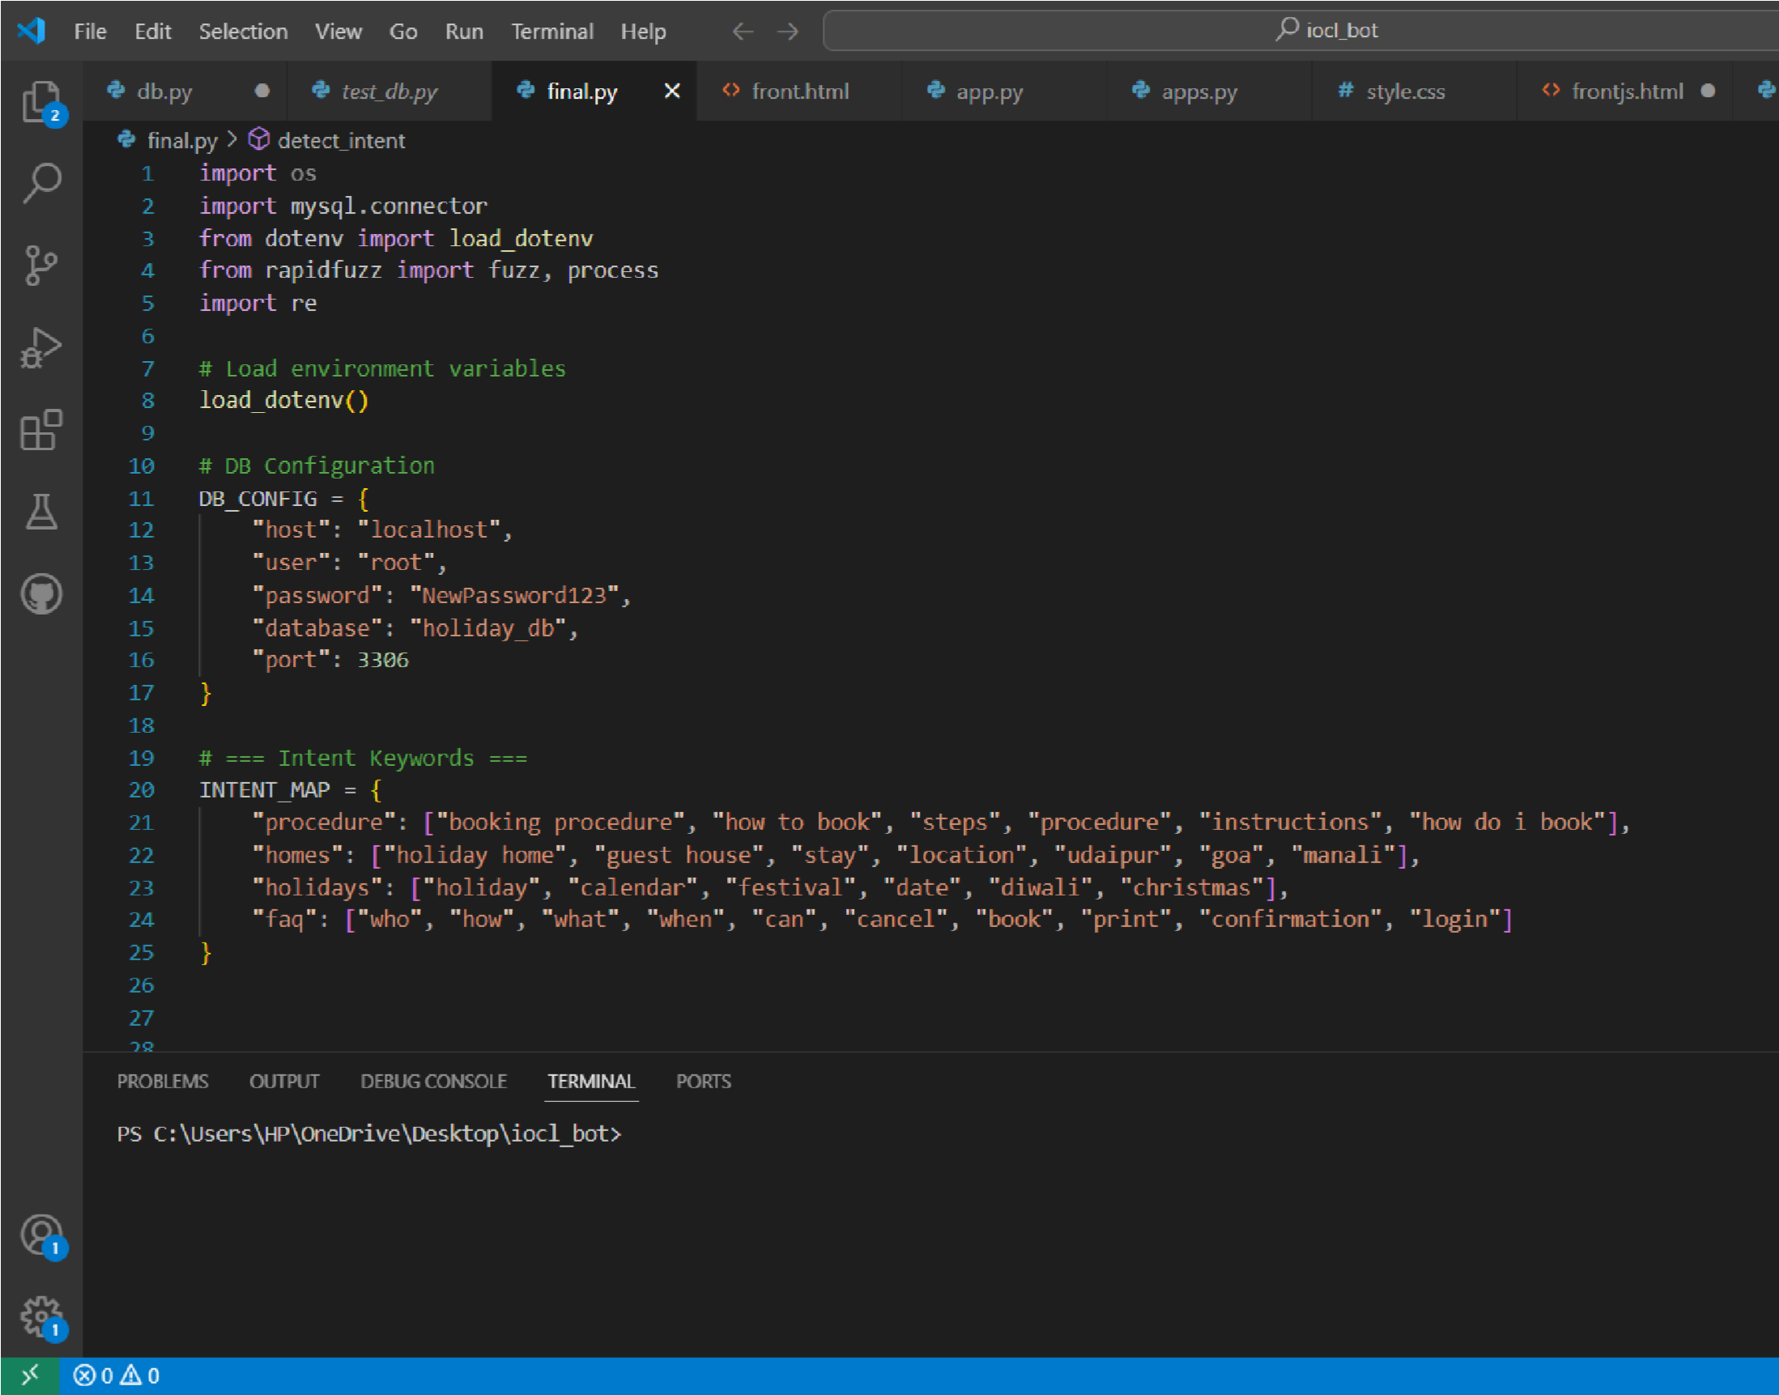

OUTPUTS

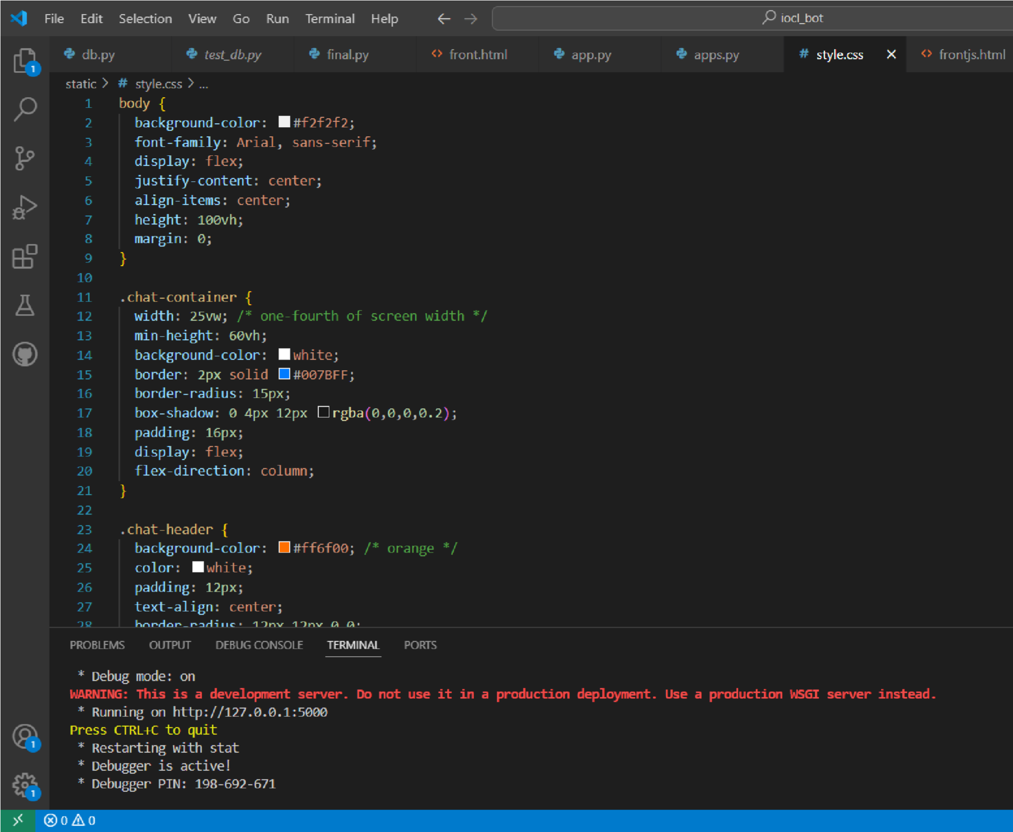

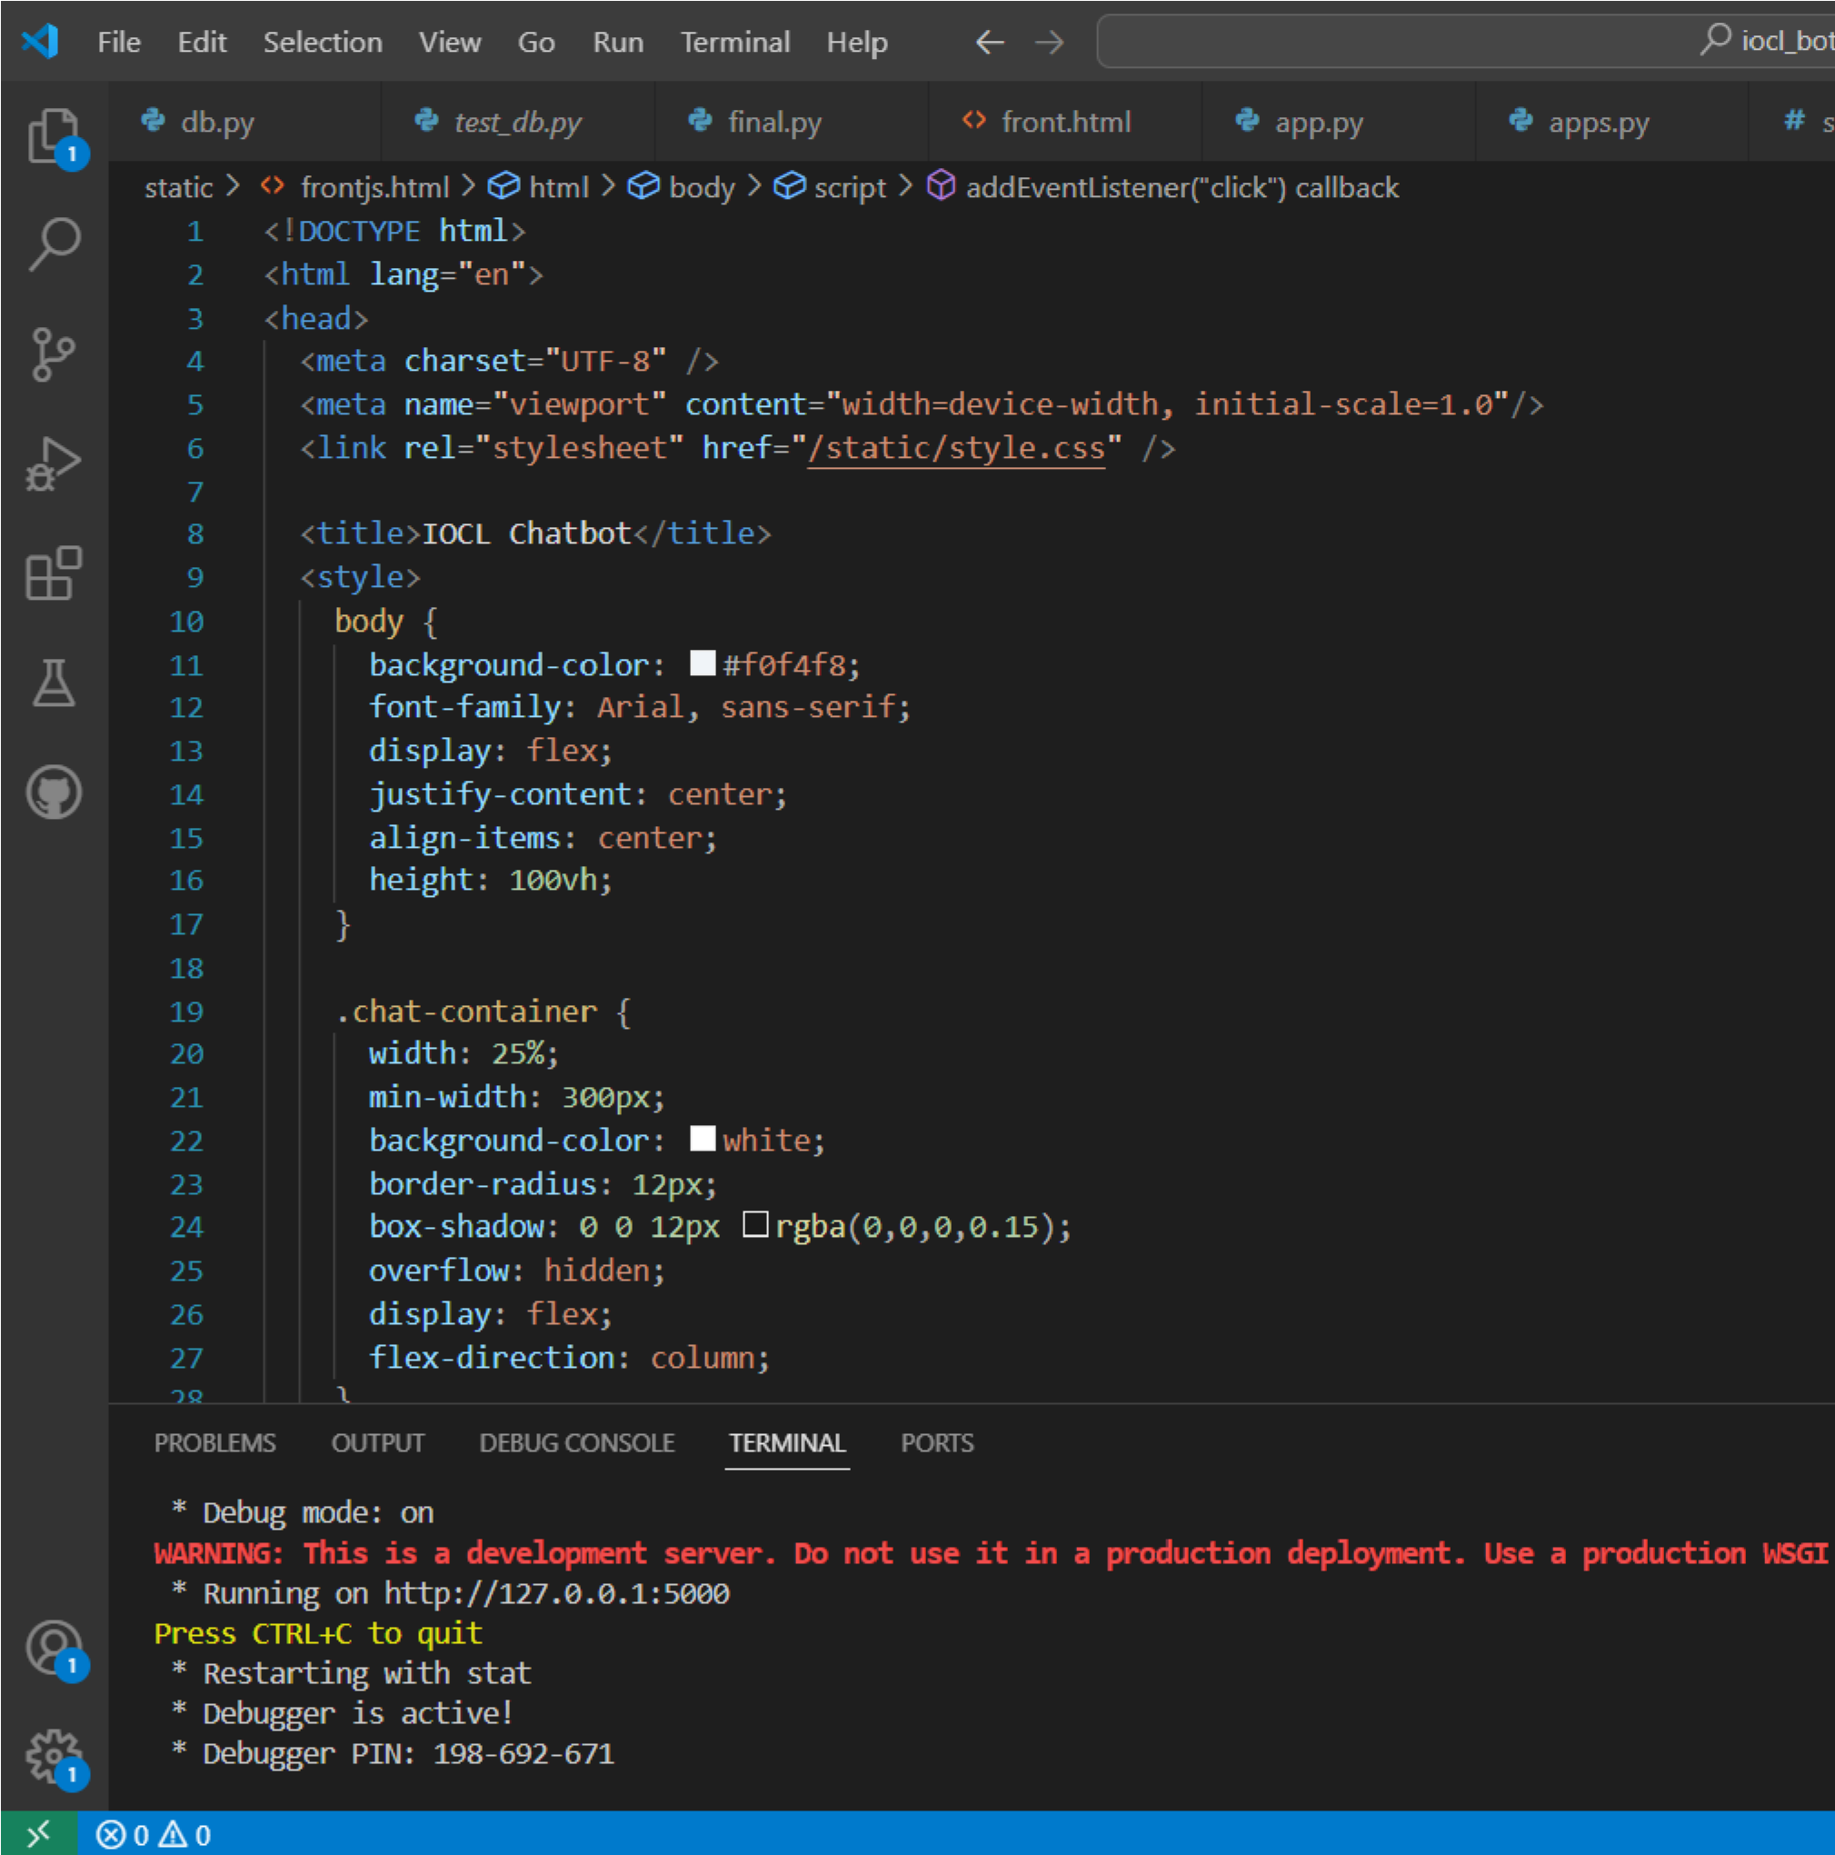

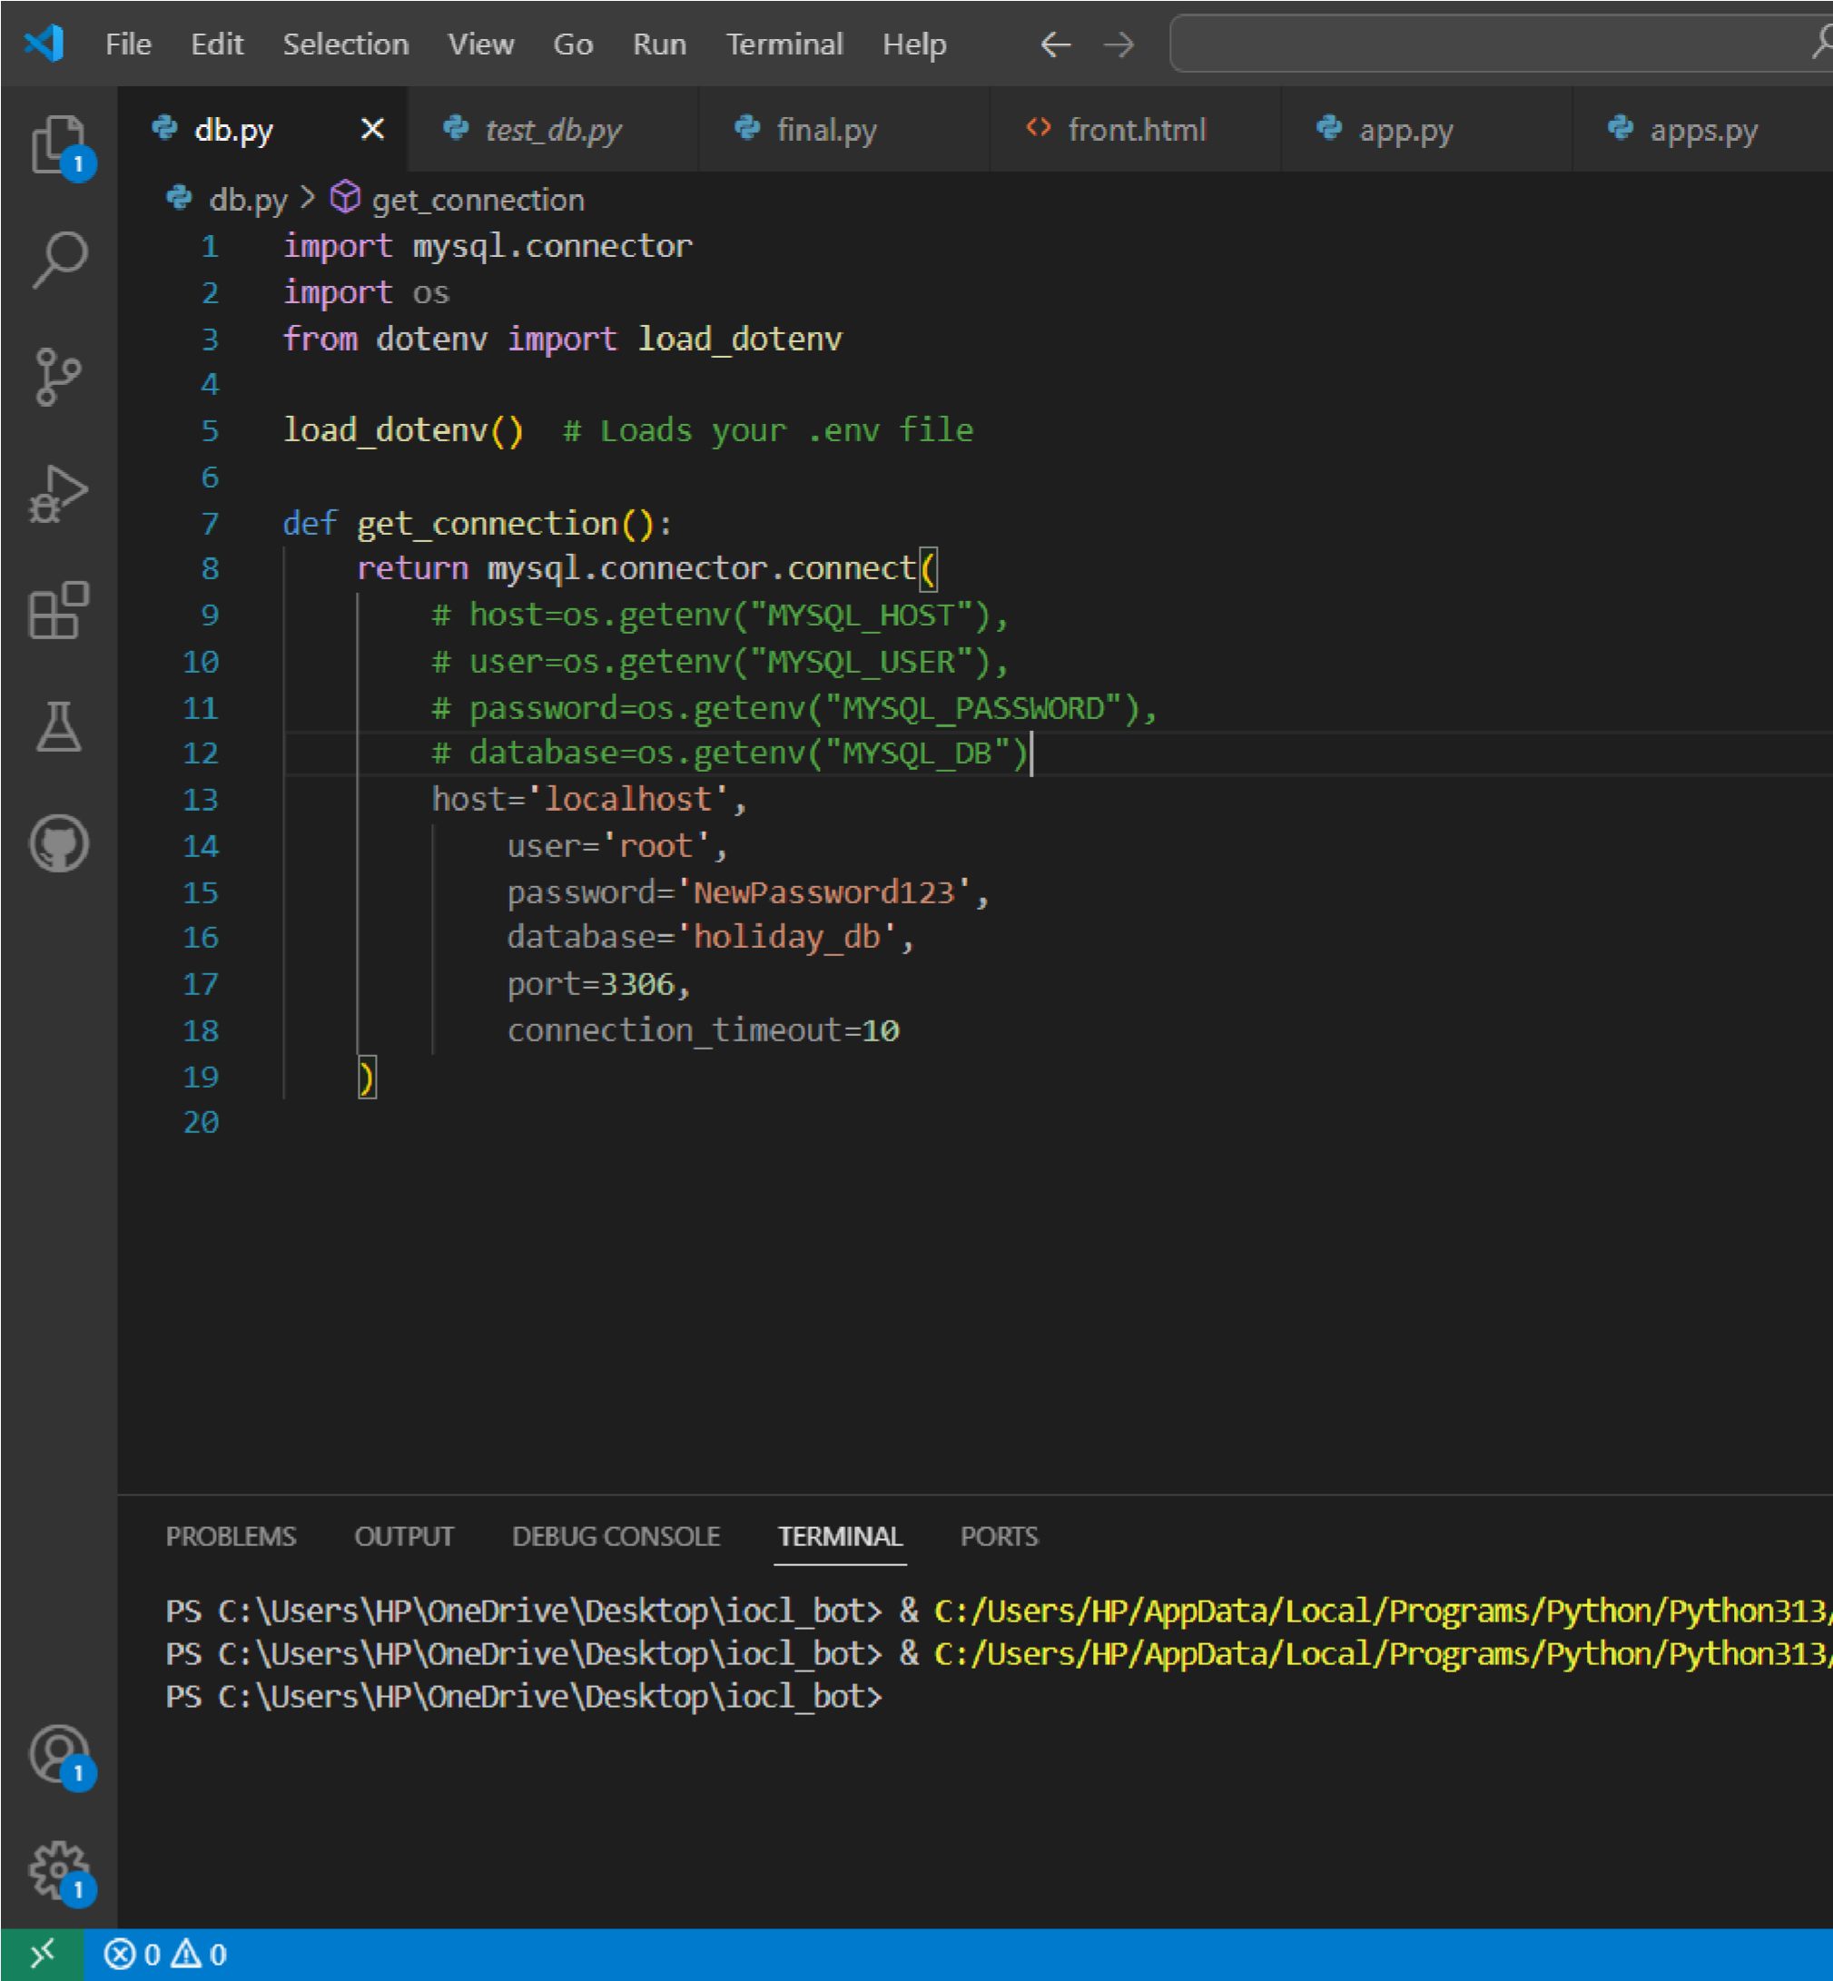

ROOT DIRECTORY STRUCTURE

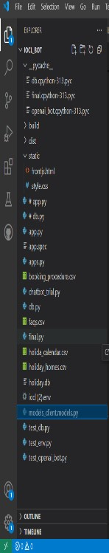

USER INTERACTION WITH THE
CHATBOT

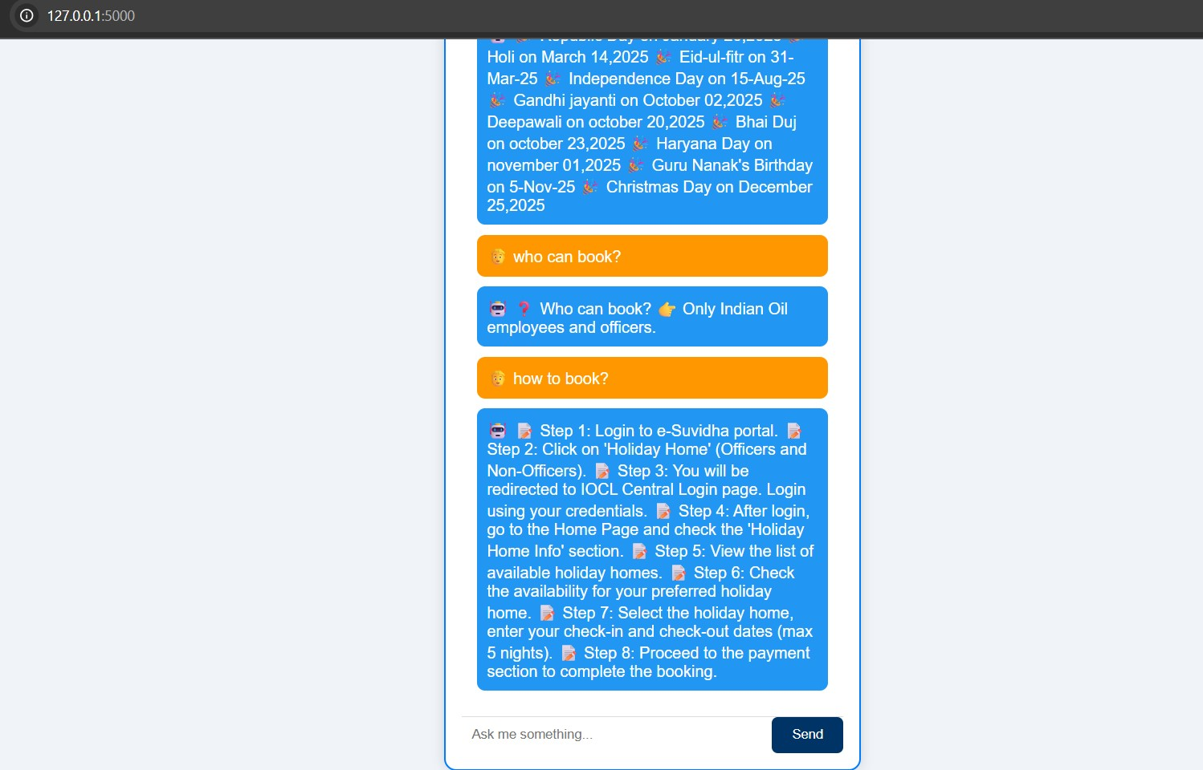

Testing
Thorough testing was conducted to validate the functionality, accuracy, and performance of the IOCL Chatbot System. The goal was to ensure that the chatbot responds appropriately to various types of user queries and handles unexpected inputs gracefully.
- Functional Testing
Each feature was tested independently to confirm that it performs as expected:
  - FAQ Queries: Tested with exact and rephrased questions. Example: “How to book?” and “Can I book a room?” both returned correct answers.
  - Holiday Calendar: Inputs like “When is Diwali?” or “List all holidays” correctly fetched data from the _{holiday_calendar} table.
  - Holiday Homes: Queries like “Show me homes in Udaipur” or “holiday home in Manali” were correctly matched and responded to.
  - Booking Procedure: Asking for “booking steps” or “procedure to book” returned the sequential instructions accurately.
- Intent Recognition Testing
Various keywords and phrases were used to test how well the system classified input into the correct category (FAQ, holidays, homes, procedure). The intent detection showed consistent and reliable performance.
- Error Handling
  - If no match was found, the bot responded with a helpful fallback message:
“Sorry, I couldn’t understand. Try asking about bookings, holidays, or FAQs.”
  - SQL errors, empty results, and invalid formats were handled using _{try-except} blocks to avoid crashes.
- Performance Testing
The response time for each query was tested and observed to be within 1–2 seconds, even with multiple requests.
•

Maintenance and Iterative Improvement
The IOCL Chatbot is designed for easy maintenance and future upgrades. Database entries like FAQs, holiday lists, and holiday home details can be updated without changing the code. Regular monitoring ensures quick fixes for bugs or incorrect responses.
Planned improvements include better intent detection using NLP, multi-language support, voice input, and admin tools for non-technical updates. With scalable design and clean structure, the system can evolve with IOCL’s growing needs while staying user-friendly and reliable.

RESULTS

The IOCL Chatbot system was successfully developed and tested to meet its core objectives. The chatbot provides instant, accurate responses to employee queries related to FAQs, holiday calendars, booking procedures, and holiday home details.
Key Outcomes:
- Responds accurately to rephrased and partial questions using keyword and fuzzy matching.
- Retrieves live data from a MySQL database for up-to-date holiday and booking information.
- Offers a clean, responsive web interface for easy interaction.
- Reduces manual workload on HR and administrative departments.
Overall, the system performed reliably across various test cases and demonstrated strong potential for real-world deployment within IOCL’s internal network.
Challenges and Solutions

Developing the IOCL Chatbot came with a few technical and functional challenges. Below are the key hurdles encountered during the project and the strategies used to overcome them:

1. Challenge: Understanding User Input Variations
Users tend to phrase similar queries in different ways, making intent detection difficult.
✅ Solution:
Implemented fuzzy string matching using the rapidfuzz library to match user queries with similar existing questions in the database. Also applied text preprocessing (lowercasing, punctuation removal) for better accuracy.

2. Challenge: Overlapping Intents
Some queries matched multiple categories (e.g., “how to book” may fit both FAQs and booking procedure).
✅ Solution:
Redefined intent logic and prioritized exact keyword matches before using fuzzy logic. Later, planned NLP integration to classify intent more accurately.

3. Challenge: Static Keyword Mapping
The keyword-based intent detection was rigid and missed some relevant queries.
✅ Solution:
Expanded keyword lists and planned a roadmap to integrate NLP models (like spaCy or BERT) for more dynamic and intelligent categorization.

4. Challenge: Displaying Structured Results
Displaying holiday homes or procedure steps clearly in the frontend required formatting.
✅ Solution:
Formatted database outputs using numbered steps and bullet points for readability in the chat interface.

5. Challenge: Flask Integration with Frontend
Making the static HTML chatbot responsive to Flask backend was initially tricky.
✅ Solution:
Used AJAX to send user input to Flask’s /ask route and return dynamic responses in JSON format.

CONCLUSION
The development of the IOCL Chatbot successfully demonstrates how conversational AI can enhance employee experience within a large enterprise like Indian Oil Corporation Limited. By combining a Flask backend, MySQL database, and a clean web interface, the chatbot enables users to access important information such as FAQs, holiday calendars, holiday home details, and booking procedures in real time.
The system reduces dependency on manual processes, streamlines internal communication, and provides a scalable solution that can evolve with organizational needs. With potential for future improvements like NLP integration, voice input, and multi-language support, this chatbot lays the foundation for smarter, automated employee support services in the public sector.

